Elevator Week 1: Sensor Calibration

**Objective**: Convert sensor measurements (volts) into height (inches)

**Deliverables:**

1.) Plot of actual height versus measured height from 10-23 inches

2.) Demonstration in TeraTerm showing real time elevator height

The figure below shows how the conversion function fits into the elevator system:

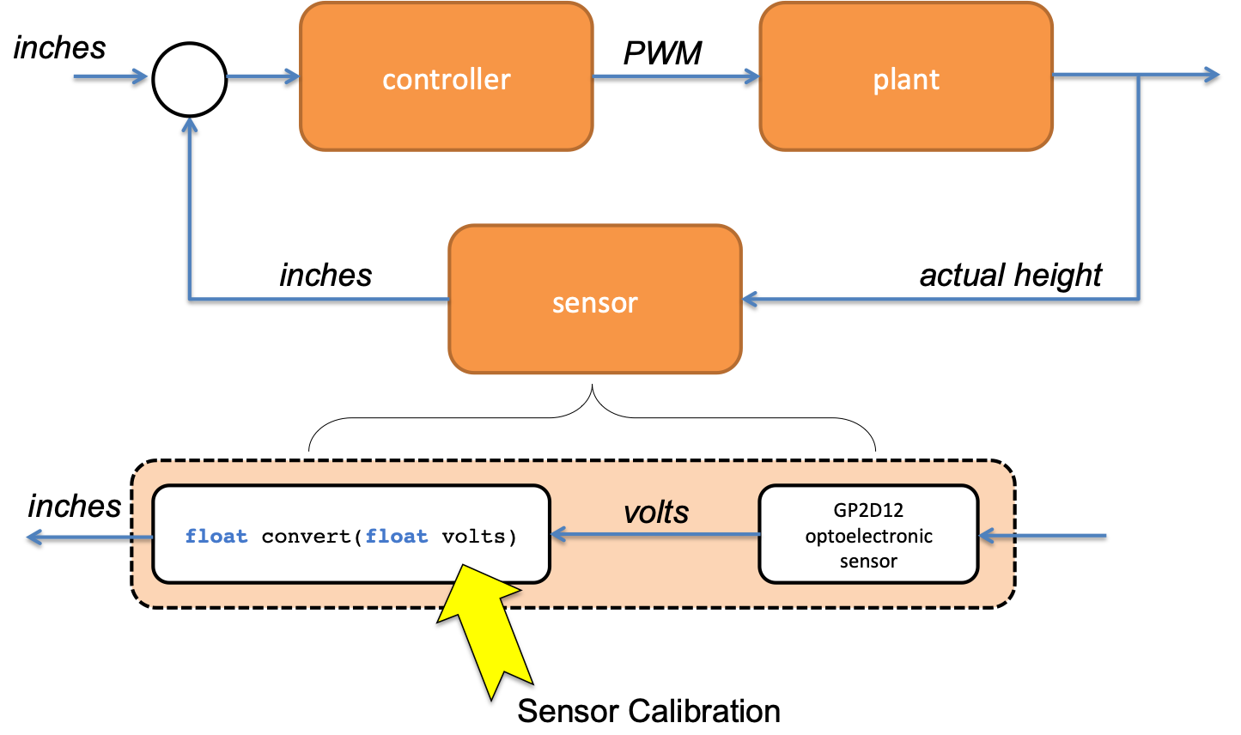

**Deliverables are due at the beginning of next lab period**

**Step 1: Data Collection**

Collect three sensor values every inch from 8-27 inches (60 measurements).

To make this process easier write an mBed program that returns three sensor readings (spaced by 0.1 seconds) when you press any key in TeraTerm. Once this works, write a MATLAB script to collect the data instead of using TeraTerm. The script should prompt the user to move the car to a specific height and wait for confirmation using the pause function. Save the data in a 20x2 matrix where the first column is car height and the second column is the average sensor reading.

**Step 2: Data Fitting**

Using the data, find an equation that maps sensor value **x**, to car height **y** over the range 10-23 inches. The equation should be of the form $y=Ax^{2}+Bx+C$

Use the curve fitting function polyfit in MATLAB to find A, B, and C. Use the help and/or doc commands to learn how to use this function

*Deliverable:*

On a single plot display actual sensor values versus predicted from your equation for the range 10-23 inches. The y-axis should be car height and the x-axis should be sensor value. Label both axes and included a legend and title.

**Step 3: Implement Sensor Calibration on the mBed**

Write a function to convert sensor values into car height. The function should accept a single float parameter and return a float. That this, the declaration should be:

**float** convert(**float** volts);

*Deliverable:*

Write an mBed program that continuously prints the car height in TeraTerm. Demonstrate to your instructor by moving the car up and down while observing the terminal output. The measured height should be within 1 inch of the actual height over the range 10-23 inches

Note: the AnalogIn.read() function returns a value between 0.0-1.0 which is technically the pin voltage as a percentage of Vout (3.3V). However for this lab you may assume AnalogIn.read() is in volts because the factor of 3.3 will automatically be included your calibration equation.